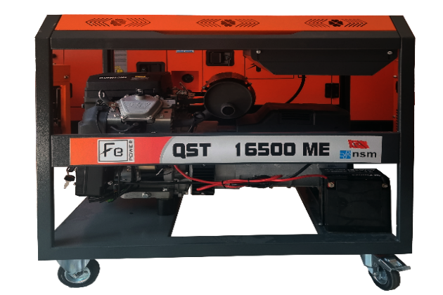

FEATURES:
Single Phase Open Frame Double Cylinders Gasoline Generator, Powered by NSM Alternator
Ideal for Charging T-40 and T-30 Agricultural Spraying Drones
 | OHV  Over Head Valve Easy To Maintenance |  | Single Plug  Possible To Getting A Full Load From A Single Plug (63 A)
 | AVR  AVR Is a Device Often Solid State, For Controlling The Output Voltage of a Generator |  | Choke System  When The Cold Weather, Choke System Aid To Operate The Engine.
 | Wheel Transport System |  | Dual Element Air Filter  Dual-Element Air Filter That Purifies The Sucked Air From Dust And Dirt

Generator |  | Engine |  | Size
Standby Power | 16.5 kVA | Model | QST2V80FE | Weight | 150 kg
Prime Power | 15 kVA | Max. Output Power | 28 hp / 20.7 kw | Width | 600 mm
Continues Rated Current | 65.25 A | Rotation Speed | 3000 / 3600 r/min | Length | 900 mm
Dc Output | 8.3 A / 12v | Cooling System | Air-Cooled | Height | 900 mm
Starting System | Electrical Start | Ignition System | TCI
Rated Voltage | 220 V | Oil Type | 10-30 or 15-40
Fuel Type | Gasoline | Fuel Tank Capacity | 20 L
Number of Phases | Single Phase | Bore×Stroke | 80 x 74 mm
Noise Level | 74 Db | Displacement | 743 mm
Continuous Operating Time | 12 H | Lubrication oil capacity | 1.7 L
Rated Frequency | 50 Hz | Engine Type | 2 Cylinder, 4Stroke, OHV, Gasoline Engine
Power Factor (cosφ) | 1.0 / 0.8

Continuous Power
The maximum power which a generating set is capable of delivering continuouslywhilst supplying a constant electrical load. Average load can be 100%. The generator must not be overloaded.
Standby Power
The maxpower available during a variable electrical power sequence, under the stated operating conditions, for which a generating set is capable of delivering in the event of a utilitypower outage or under test conditions for up to 200 hrs of operation per year under average of 70%load.Overloading isn’t permissible.
Prime Power
The maximum power which a generating set is capable of delivering continuouslywhilst supplying a variable electrical load. Average load should be 70%. The generator can be overloaded 10% for 1 hour per 12 hrs.

