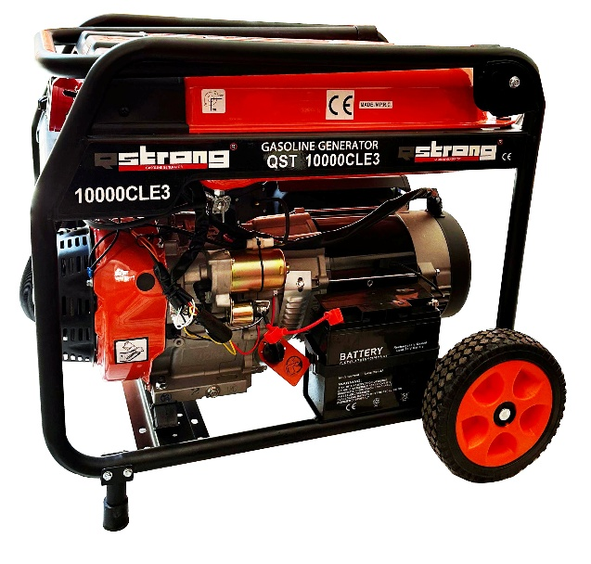 |  | 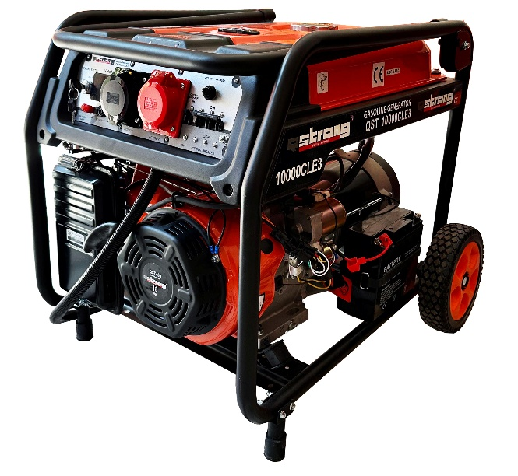
FEATURES:
Three Phase & Single phase Switchable Equal Power Open Type Gasoline Generator
 | OHV  Over Head Valve easy to maintenance |  |  | Circuit Protector  Circuit Protector is a device capable of carrying and interrupting both load and fault current up to a certain rating
 | Oil Level Alarm  When the oil level is low that the engine will not start. |  |  | Voltmeter  It is a gauge for output voltage of generator set.
 | AVR  AVR is a device often solid state, for controlling the output voltage of a generator |  |  | Choke System  When the cold weather, choke system aid to operate the engine.
 | Wheel Transport System |  |  | Dual Element Air Filter  Dual-element air filter that purifies the sucked air from dust and dirt
 |  |  |  | Switchable Single Phase & Three Phase  The possibility of switching between single 220V and three phases 380V

Generator |  | Engine |  | Size
Standby Power | 10 kVA | Model | QST 460 | Weight | 74 kg
Prime Power | 9 kVA | Max. Output Power | 18 hp /13.3 kW | Width | 520 mm
Continues Rated Current | 39.15 / 38.88 A | Rotation Speed | 3000 / 3600 r/min | Length | 700 mm
Dc Output | 8.3 A / 12v | Cooling System | Air-Cooled | Height | 570 mm
Starting System | Electrical Start | Oil Type | 10-30 or 15-40
Rated Voltage | 220 / 380 V | Fuel Tank Capacity | 33 L
Fuel Type | Gasoline | Bore × Stroke | 92 x 69 mm
Number of Phases | Three / Single Phase Equal Power | Displacement | 0.460 L
Noise Level | 74 Db | Lubrication oil capacity | 1.1 L
Continuous Operating Time | 12 H | Engine Type | 1-Cylinder, 4-Stroke, OHV, Gasoline Engine
Rated Frequency | 60 / 50 Hz
Power Factor (cosφ) | 1.0 / 0.8

Continuous Power
The maximum power which a generating set is capable of delivering continuouslywhilst supplying a constant electrical load. Average load can be 100%. The generator must not be overloaded.
Standby Power
The maxpower available during a variable electrical power sequence, under the stated operating conditions, for which a generating set is capable of delivering in the event of a utilitypower outage or under test conditions for up to 200 hrs of operation per year under average of 70%load.Overloading isn’t permissible.
Prime Power
The maximum power which a generating set is capable of delivering continuouslywhilst supplying a variable electrical load. Average load should be 70%. The generator can be overloaded 10% for 1 hour per 12 hrs.

