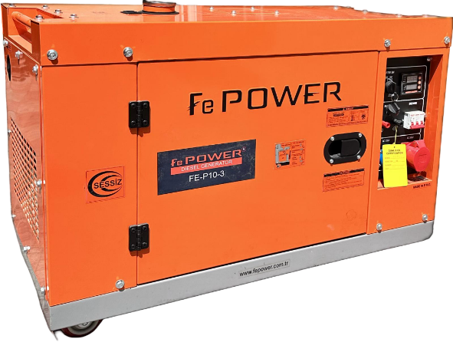 |  | 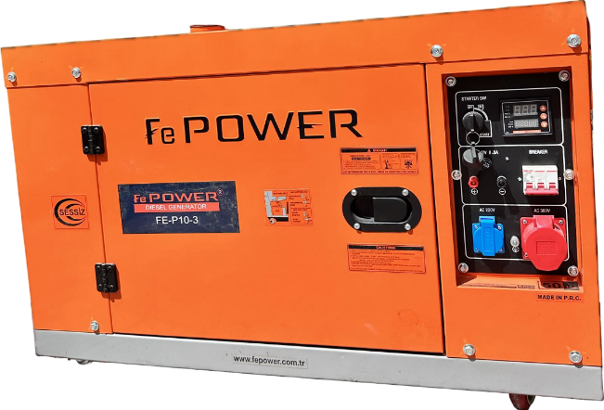
FEATURES:
Three Phase Silent Type Diesel Generator
 | Oil Level Alarm  When the oil level is low that the engine will not start. |  |  | Circuit Protector  Circuit Protector is a device capable of carrying and interrupting both load and fault current up to a certain rating
 | AVR  AVR is a device often solid state, for controlling the output voltage of a generator |  |  | Large Fuel Tank Capacity
 | Digital Control Panel  Digital control panel (V, A, Hz, kW, Bat V values are displayed on the control panel). |  |  | Battery  12 V – 36 A
 | Sound Insulated Protection Cabins  Its designed to provide ideal sound level & protection. |  |  | Wheel Transport System
 |  |  |  | ATS Socket

Generator |  | Engine |  | Size
Standby Power | 10 kVA | Model | 195FE | Weight | 185/190 kg
Prime Power | 9 kVA | Max. Output Power | 13 hp / 9.6 kW | Width | 1120 mm
Continues Rated Current | 38.88 A | Rotation Speed | 3000 / 3600 r/min | Length | 545 mm
Dc Output | 12V 8.3A | Cooling System | Air-Cooled | Height | 705 mm
Starting System | Electrical Start | Excitation Mode | SCR Self-Excited
Rated Voltage | 220 / 380 V | Oil Type | 10-30 or 15-40
Fuel Type | Diesel | Fuel Tank Capacity | 16 L
Number of Phases: | Single / Three Phase | Bore × Stroke | 95 x 75 mm
Noise Level | 78 Db | Displacement | 0.535 L
Continuous Operating Time | 12 H | Lubrication oil capacity | 1.65 L
Rated Frequency | 50 / 60 Hz | Engine Type | 1 Cylinder, 4-Stroke, Direct Injection, Diesel Engine
Power Factor (cosφ) | 1.0 / 0.8

Continuous Power
The maximum power which a generating set is capable of delivering continuouslywhilst supplying a constant electrical load. Average load can be 100%. The generator must not be overloaded.
Standby Power
The max. power available during a variable electrical power sequence, under the stated operating conditions, for which a generating set is capable of delivering in the event of a utilitypower outage or under test conditions for up to 200 hrs of operation per year under average of 70%load.Overloading isn’t permissible.
Prime Power
The maximum power which a generating set is capable of delivering continuouslywhilst supplying a variable electrical load. Average load should be 70%. The generator can be overloaded 10% for 1 hour per 12 hrs.

